**Exploring IPFS for Decentralized File Storage**

For this task, I used the previously installed ipfs software which I had downloaded for spider workshop on statik. I’ve created an js file for this task where I’ve installed ipfs-http-client module and the bit bash command for it is “npm i ipfs-http-client” , after importing it and changing package .json file for adding module and the command I’ve added is “"type" :"module",” . And then I’ve referred to tutorial in youtube for **Storing and Retrieving files in IPFS using NodeJS**

And the link is <https://youtu.be/jI6wcuY8p2Y?si=mLDv_8R7ZjpRxXzB>

Task:

1. The text file which I’ve sent is given below

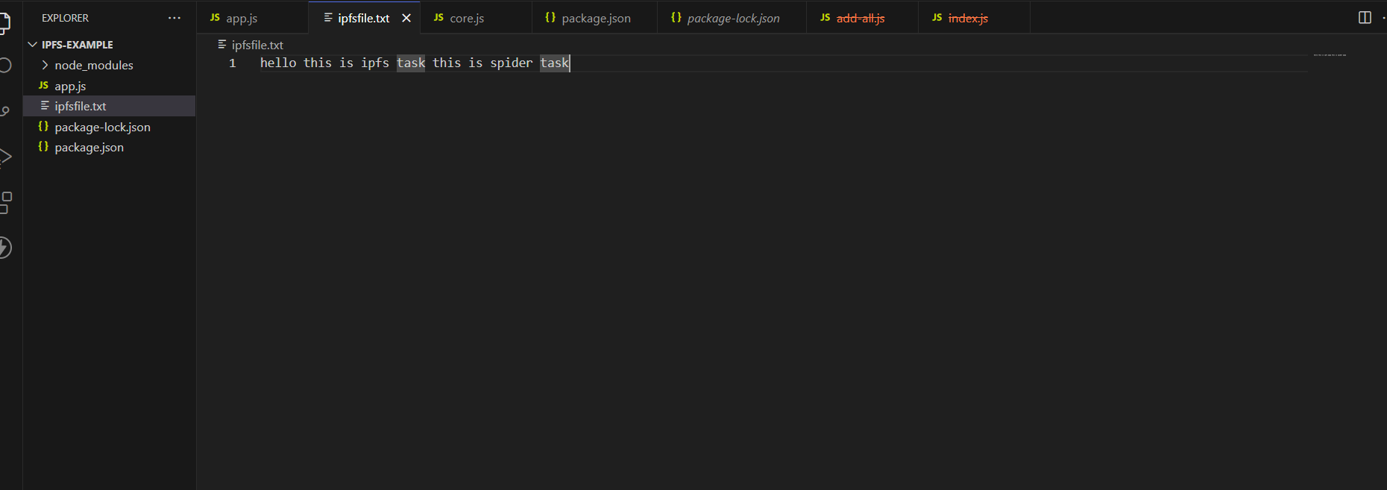

1. After sending data , when I’ve used “ipfs.io/ipfs/<cid>” for checking the data is being sent.

The output is 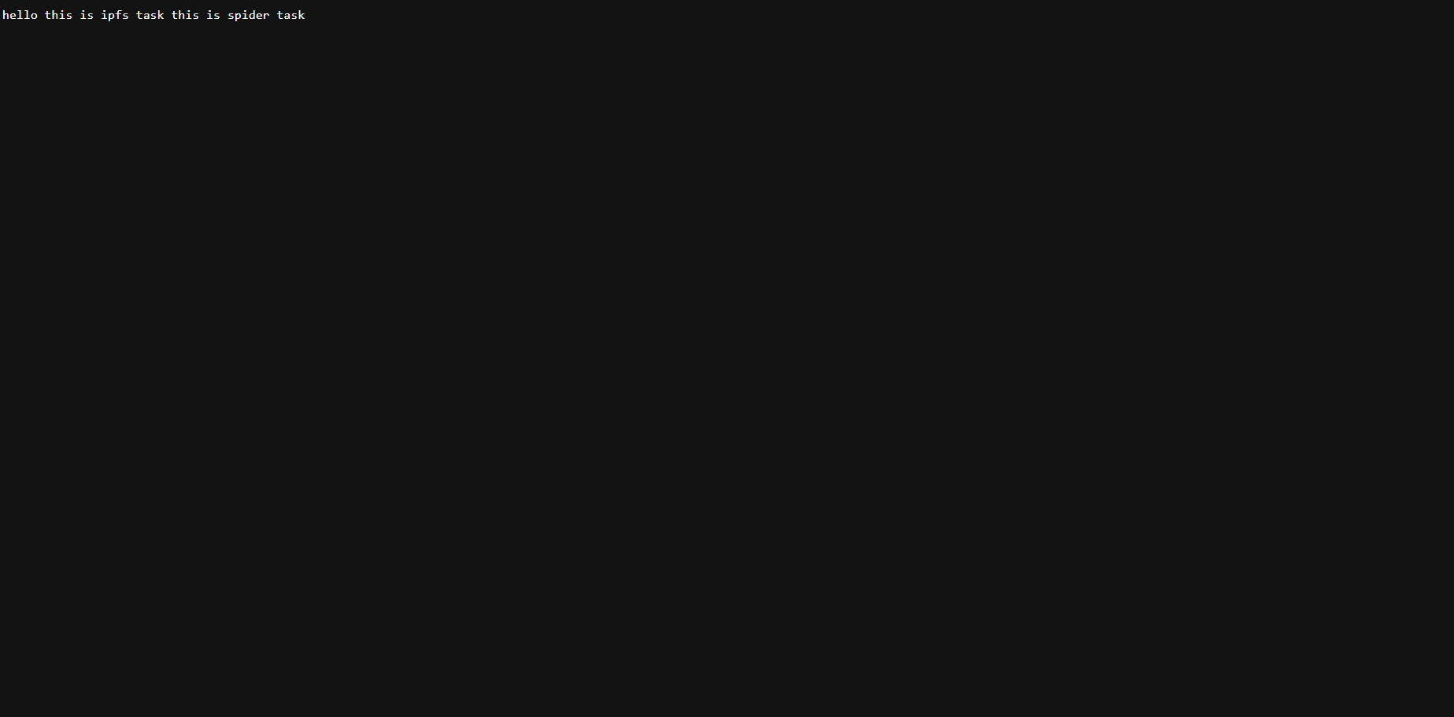

1. Then I’ve used that cid to retrieve the data from ipfs

And the output is